**EXERCISE 2.1 - Getting Started with Django**

Name: Ivan Cortes

Date: 10/08/2025

Course: CareerFoundry - Python for Web Developers

**PART 1: THEORY QUESTIONS**

Question 1: Why is Django so popular?

Django is popular because it helps developers build secure, scalable websites quickly. It comes with built-in tools like user login systems, admin dashboards, and database connections, so you don’t have to build everything from scratch. It’s written in Python, which is easy to learn and widely used. Django also has strong documentation and a large community, which makes it easier to get help and find solutions when you’re stuck.

Question 2: Five Companies That Use Django

1. **Instagram** – Uses Django to manage user accounts, media uploads, and the content feed.
2. **Spotify** – Uses Django for internal tools like data dashboards and payment systems.
3. **NASA** – Their public website runs on Django, handling lots of content securely.
4. **Disqus** – Built its global comment system with Django, serving millions of users.
5. **Pinterest** – Uses Django to manage pins, boards, and personalized content delivery.

Question 3: When Should You Use Django?

Scenario A: You need a web app with multiple users.  
Yes – Django has built-in tools for user accounts and permissions.

Scenario B: You want to build fast and make changes as you go.  
Yes – Django’s structure and database tools make it easy to update and grow your project.

Scenario C: You’re building something very simple without a database.  
No – Django is too complex for basic apps. Use something lighter like Flask.

Scenario D: You want full control over every part of your app.  
Not ideal – Django has a set way of doing things. If you want to customize everything, Flask might be better.

Scenario E: You’re starting a big project and want support.  
Yes – Django has great documentation and a huge community, so it’s easier to get help.

**PART 2: TECHNICAL SETUP SCREENSHOTS**  
  
Screenshot 1: Python Version Verification



Screenshot 2: Virtual Environment Activated

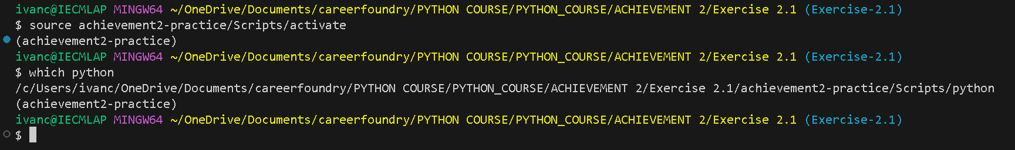

Screenshot 3: Django Installation Complete

